DIGITAL MARKETING

Assignment 2- Creating a facebook page and posting a social media

Poster

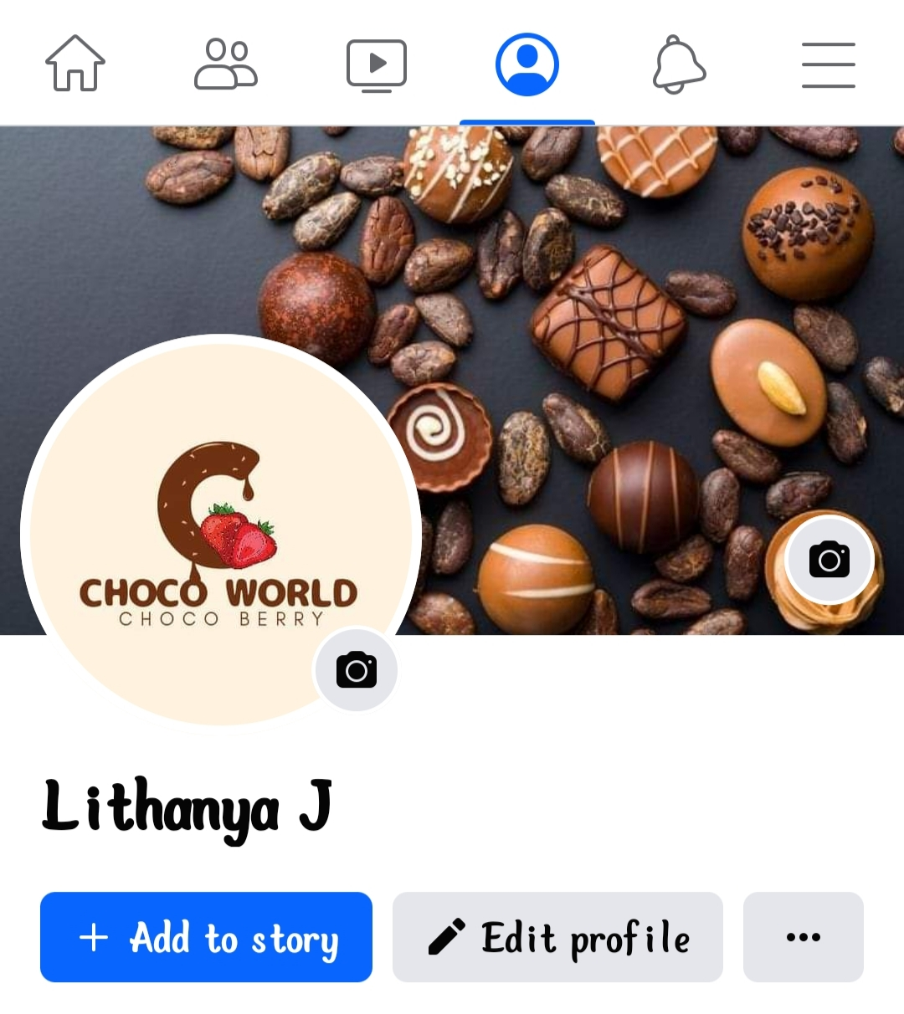

Figure: facebook profile



Figure: Social media poster

Facebook post link:

<https://www.facebook.com/61552723710488/posts/pfbid029xs3BFYsCLEhkm2pdZbB5aj9DtSRB7SY5io5mY4F5vAmHX93ANpd3xSsEftvXyPYl/?mibextid=Nif5oz>